IntroGIS – Introduction to Geographic Information Systems (GIS)

Week 01

**Assignment Instructions**

1. If you plan to install the software on your own computer, order the textbook – it has instructions for downloading the software we will be using and must be installed for next week’s assignment. If the book doesn’t arrive on time, you will have to use the software in the lab until you can install it. Assignments can’t be submitted late!
2. Make sure you can access Blackboard.
3. Make sure you have forwarded your Pace email to your home email (if you use a mail account other than your Pace account).
4. Read the Procedures document and the Syllabus in the Course Information section.
5. ***Due Tuesday 9/10 -*** Email me a short note indicating that you are accessing Blackboard. The form of an email must have the subject: *IntroGIS - yourlastname – subject.*  For example if your last name is *Smith* the subject line must read *IntroGIS – Smith – this is the subject*. This format must be used for all email this semester or it may not be responded to!
6. ***Due Tuesday 9/10 -*** Use the discussion forum *IntroGIS - Introductions* to give some information about yourself. Post a new thread which includes:

* Name
* Program (e.g. BS/IT, BS/IS, MS/IS)
* The year you plan to graduate
* Employment information (where, what, etc.)
* Information Technology background (HTML, Java, WebSite development, etc.)
* Anything else of interest - hobbies, activities
* Why you are taking the class (e.g. required, interested, work in GIS)?

1. **Due *Tuesday 9/10*** – Complete the Google Maps mapping Assignment below
2. **Due *Tuesday* 9/10** - In the folder for Week 1, there is a link to a survey. Take the survey

***Summary of what is due for Week01:***

1. Your Intro in the Discussion Forum
2. View the two screen videos (in the Course Information Section)
3. Google Maps assignment
4. Completed Survey

NOTE. There is always a 24 hour grace period. This means that homework can be submitted up to 1 day after the due date (effectively one extra day). When there are links for submission, they will not be available after the grace period (no exceptions!).

**Getting Help.** Please use the Discussion Board to post and respond to questions. If you don’t get a response, please feel free to email me. Use the Forum: *IntroGIS – Questions and Comments*.

**Mapping Assignment**

There are 2 videos in the Course Information Folder for Week 1:

1. Geographic Information Systems Overview
2. Creating Point Maps with Google Maps.

Please look at both – the first is a conceptual overview of GIS, and the second will help you with this week’s mapping assignment – we will have videos of this type for most assignments.

In this week’s assignment we will use Google Maps to create a map of information about the 50 states in the US. The assignment assumes you have used Google Maps and minimally know how to find a location and pan and zoom (if not – it’s a quick study). Each of you will be assigned a region and a number of states and will create a map with points and information for each state in your region. If you don’t see your name in the list below, choose any region. I’ve defined 10 regions based on the U. S. Office of Management and Budget regions. Use the region assigned to you. If there is no data for a state in your region – in the point you create (you’ll know what this means later), just say no data available.

For each state you will create a Google Maps point and enter the data as indicated in the table/list at the end of the assignment description.

We will see that while Google Maps is a powerful application for creating and displaying information, it has limited capability when it comes to analyzing location-based data.

***Using Google Maps (the video goes through these steps)***

1. Go to [http:// maps.google. com](http://google.maps.com) *sign in* to Google maps. If you have Google account, use it, if not *sign in*, click on “Sign in with a new account and select create a Google account. Log in to Google Maps.
2. To the left of the Google maps search bar is a pull down menu. Select “Your Places”. Choose the Maps tab and select “Create” (at the bottom). Title the map with your last name and the name of your region by clicking on “Untitled Map”. For example, New York is in “Region 2”.

IMPORTANT. Give it the name, yourlastname *Region (e.g., Farkas – Region 2)*

NOTE. This will identify the map (it’s not in the video)

1. Enter an optional description and Save.
2. Name the layer the Region number and Save.
3. We will add points and data to the map using the data at the end of this document. Let’s assume the state you are working on is New York.
4. Looking at the list of capitals at the end of this document, we see that Albany is the capital of New York. Using to search bar at the top, navigate to “Albany, NY”
5. There are a few alternatives here – one is to use the point established:
6. In the pop-up, click “+ Add to Map
7. Select the “Edit” icon at the bottom (second from left)
8. Change the name from Albany to New York (we are more interested in the state name)
9. In the text box, list the New York data for Total, Crop, Range, and Forest
10. NOTE – to have multiple lines in the text box you have to type ctrl-enter.
11. “Save” the point
12. Do the same procedure for each state/point in your region.
13. Another alternative, which allows for placing points anywhere on the map:

* Click on the Paddle under the search text box. Move your cursor (a little “+”) anywhere on the map. Proceed as above to establish a name and data and then click save.

1. NOTE. A right click allows you to delete the point.

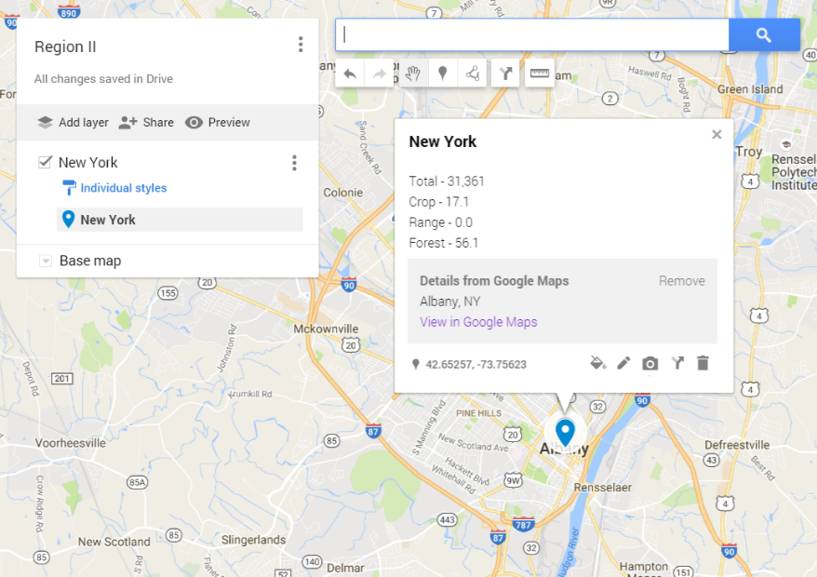

1. Continue to add all the states in your region
2. When you have added all the state information refresh the original Google Maps page. You should see your map in the list of maps in the Maps tab.
3. NOTE. If there is no data for a particular state, just enter “n/a”.

***Sharing the Map***

1. IMPORTANT. So that I can see the map (and grade it) you will have to send me a link. This is done with the *Share button* in the middle of the panel on the left. Click “Change” and change the Access to “Anyone with the Link”. Place the link in the Assignment link for this week’s folder.

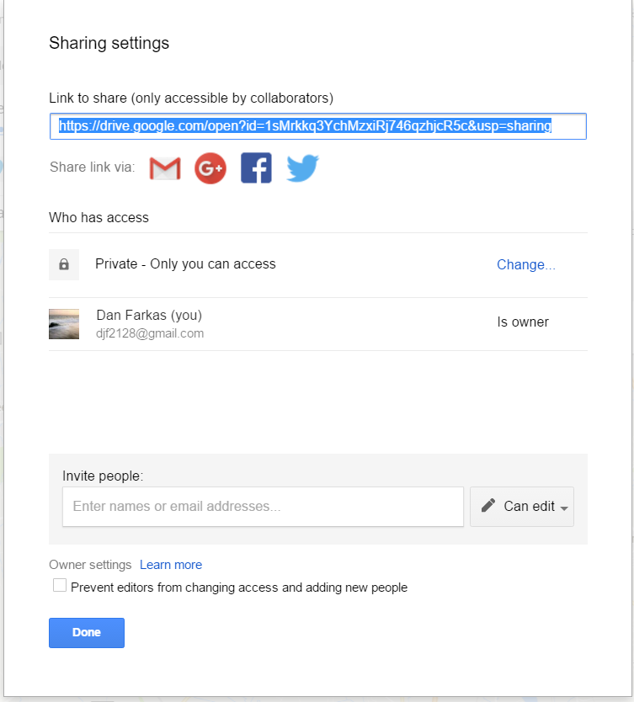

***Importing a Layer***

In this part of the exercise we will import the data table as an excel spreadsheet noting that there is an address (State Name) and attributes for each state (land use data). The spreadsheet is uploaded to the folder for this week.

1. Download the spreadsheet from this week’s folder in Blackboard.

You should set it up having a folder off the root of your main drive (this can be a flash drive) with the following naming convention: *X:* \lastname\WEEKnumber

For example for me: c*:\farkas\week02;* Note that it is all lowercase.

This will be important later for sending me copies of your GIS models/assignments. It will also organize what can me come a significant number of files.

1. Create a new map.
2. IMPORTANT. Give it the name, yourlastname *Land Usage*

NOTE. This will identify the map (it’s not in the video)

1. Give the Layer a name, *US Land Usage*
2. Under the Layer name, select import
3. Select the “Select a file from your device” button and navigate to the data file
4. Select the field name that has the address components. In this case there is only the State name.
5. Select Continue

Google maps will import the file and “Geocode” the address – essentially assigning a latitude and longitude. We’ll more to say about geocoding later in the semester.

1. Customize the map by coloring the points. We will color them by the value the crop usage. But also notice other options in the video.
2. Select “Uniform Style” which gives a pull down of options. Select “Style by Data Column”. The default is to use the value to”categorize” or “Classify” the points. This isn’t that interesting in this case since they all have unique values. Select ranges. This will color (and classify) asccodint to ranges of values.
3. Once this is done, get the “share” link. Place the link in the upload link in the Week’s assignment folder.

***Summary of what is due for Week01:***

1. Your Intro in the Discussion Forum
2. View the screen video (in the Course Information Section)
3. View the GIS Overview Video
4. Google Maps assignment
5. Completed Survey

NOTE. There is always a 24 hour grace period. This means that homework can be submitted up to 1 day after the due date (effectively one extra day). When there are links for submission, they will not be available after the grace period (no exceptions!).

**Getting Help.** Please use the Discussion Board to post and respond to questions. If you don’t get a response, please feel free to email me. Use the Forum: *IntroGIS – Questions and Comments*.

|  |
| --- |
| **Region** |
| Region 1: Connecticut, Maine, Massachusetts, New Hampshire, Rhode Island, Vermont |
| Region 2: New Jersey, New York |
| Region 3: Delaware, Maryland, Pennsylvania, Virginia, West Virginia |
| Region 4: Alabama, Florida, Georgia, Kentucky, Mississippi, North Carolina, South Carolina, Tennessee |
| Region 5: Illinois, Indiana, Michigan, Minnesota, Ohio, Wisconsin |
| Region 6: Arkansas, Louisiana, New Mexico, Oklahoma, Texas |
| Region 7: Iowa, Kansas, Missouri, Nebraska |
| Region 8: Colorado, Montana, North Dakota, South Dakota, Utah, Wyoming |
| Region 9: Arizona, California, Hawaii, Nevada Region |
| Region 10: Alaska, Idaho, Oregon, Washington |

**Region Assignments**

|  |  |  |  |  |  |  |  |  |  |  |  |  |  |  |  |  |  |  |  |  |  |  |  |  |  |  |  |  |  |  |  |  |  |  |  |  |  |  |  |  |  |  |  |  |  |  |  |  |  |  |  |  |  |  |  |  |  |  |  |  |  |  |  |  |  |  |  |  |  |  |  |  |  |  |  |  |  |  |  |  |  |  |  |  |  |  |  |  |  |  |  |  |  |  |  |  |  |  |  |  |  |  |  |  |  |  |  |  |  |  |  |  |  |  |  |  |  |  |  |  |  |  |  |  |  |  |  |  |  |  |  |  |  |  |  |  |  |  |  |  |  |  |  |  |  |  |  |  |  |  |  |
| --- | --- | --- | --- | --- | --- | --- | --- | --- | --- | --- | --- | --- | --- | --- | --- | --- | --- | --- | --- | --- | --- | --- | --- | --- | --- | --- | --- | --- | --- | --- | --- | --- | --- | --- | --- | --- | --- | --- | --- | --- | --- | --- | --- | --- | --- | --- | --- | --- | --- | --- | --- | --- | --- | --- | --- | --- | --- | --- | --- | --- | --- | --- | --- | --- | --- | --- | --- | --- | --- | --- | --- | --- | --- | --- | --- | --- | --- | --- | --- | --- | --- | --- | --- | --- | --- | --- | --- | --- | --- | --- | --- | --- | --- | --- | --- | --- | --- | --- | --- | --- | --- | --- | --- | --- | --- | --- | --- | --- | --- | --- | --- | --- | --- | --- | --- | --- | --- | --- | --- | --- | --- | --- | --- | --- | --- | --- | --- | --- | --- | --- | --- | --- | --- | --- | --- | --- | --- | --- | --- | --- | --- | --- | --- | --- | --- | --- | --- | --- | --- | --- | --- |
| |  |  |  | | --- | --- | --- | | Adriana | Lobato | Region 01 | | Chriselle | Johnson | Region 01 | | James | Hammond | Region 01 | | Micah | Steele | Region 01 | | Roydon | Quadros | Region 01 | | Aishwarya Sunil | Kate | Region 02 | | Christopher | Cherestal | Region 02 | | John | Cronin | Region 02 | | Mohammed Fraz | Khan | Region 02 | | Rushi | Shukla | Region 02 | | Akanksha | Mohite | Region 03 | | Cyrroni | Smith | Region 03 | | Justin | Brandon | Region 03 | | Nayan | Kumar | Region 03 | | Sankalp Ramanand | Redgaonkar | Region 03 | | Amar | Suryawanshi | Region 04 | | Edward | Wong | Region 04 | | Justin | Valis | Region 04 | | Neelambari | Nawale | Region 04 | | Shashikant | Prajapati | Region 04 | | Amit | Tewari | Region 05 | | Elizabeth | Nesi | Region 05 | | Karan Jaydeepbhai | Doshi | Region 05 | | Partth | Ghelaa | Region 05 | | Shraddha | Bhavsar | Region 05 | | |  |  |  | | --- | --- | --- | | Aramis | Gaston | Region 06 | | Eric | Anderson | Region 06 | | Ketaki Vijay | Divekar | Region 06 | | Pooja Ravindra | Deore | Region 06 | | Sourabh | Teli | Region 06 | | Austin | Harisch | Region 07 | | Ezana | Ceman | Region 07 | | Kiran | Benny | Region 07 | | Pranav | Giri | Region 07 | | Tyson | Titus | Region 07 | | Bhavin | Shekhada | Region 08 | | Harshil | Shah | Region 08 | | Kshitija | Jadhav | Region 08 | | Pranitha | Nukala | Region 08 | | Udayan | Sawant | Region 08 | | Billy | Guo | Region 09 | | Heather | Farley | Region 09 | | Lilin | Ou | Region 09 | | Precious | Hose | Region 09 | | Victor | Sarmiento | Region 09 | | Chris | Pelosi | Region 10 | | Jacob | Adukuzhiyil | Region 10 | | Manali | Mane | Region 10 | | Rey | Kam | Region 10 | | Vimal | Nair | Region 10 | |

**State Capitals**

|  |  |
| --- | --- |
| **State** | **Capital** |
| Alabama | Montgomery |
| Alaska | Juneau |
| Arizona | Phoenix |
| Arkansas | Little Rock |
| California | Sacramento |
| Colorado | Denver |
| Connecticut | Hartford |
| Delaware | Dover |
| Florida | Tallahassee |
| Georgia | Atlanta |
| Hawaii | Honolulu |
| Idaho | Boise |
| Illinois | Springfield |
| Indiana | Indianapolis |
| Iowa | Des Moines |
| Kansas | Topeka |
| Kentucky | Frankfort |
| Louisiana | Baton Rouge |
| Maine | Augusta |
| Maryland | Annapolis |
| Massachusetts | Boston |
| Michigan | Lansing |
| Minnesota | St. Paul |
| Mississippi | Jackson |
| Missouri | Jefferson City |
| Montana | Helena |
| Nebraska | Lincoln |
| Nevada | Carson City |
| New Hampshire | Concord |
| New Jersey | Trenton |
| New Mexico | Santa Fe |
| New York | Albany |
| North Carolina | Raleigh |
| North Dakota | Bismarck |
| Ohio | Columbus |
| Oklahoma | Oklahoma City |
| Oregon | Salem |
| Pennsylvania | Harrisburg |
| Rhode Island | Providence |
| South Carolina | Columbia |
| South Dakota | Pierre |
| Tennessee | Nashville |
| Texas | Austin |
| Utah | Salt Lake City |
| Vermont | Montpelier |
| Virginia | Richmond |
| Washington | Olympia |
| West Virginia | Charleston |
| Wisconsin | Madison |
| Wyoming | Cheyenne |

**Land Usage Data**

|  |  |  |  |  |
| --- | --- | --- | --- | --- |
| **State** | **Total** | **Crop** | **Range** | **Forest** |
| Alabama | 33,424 | 7.5 | 0.2 | 64.4 |
| Arizona | 72,964 | 1.3 | 44.2 | 5.7 |
| Arkansas | 34,037 | 22.1 | 0.1 | 44.1 |
| California | 101,510 | 9.3 | 17.5 | 13.7 |
| Colorado | 66,625 | 12.5 | 37.2 | 4.9 |
| Connecticut | 3,195 | 5.4 | 0 | 53.4 |
| Delaware | 1,534 | 29.8 | 0 | 22.2 |
| Florida | 37,534 | 7.7 | 7.2 | 33.9 |
| Georgia | 37,741 | 11.0 | 0 | 58.0 |
| Idaho | 53,488 | 10.2 | 12.0 | 7.5 |
| Illinois | 36,059 | 66.5 | 0 | 11.0 |
| Indiana | 23,158 | 57.5 | 0 | 16.5 |
| Iowa | 36,017 | 70.8 | 0 | 6.4 |
| Kansas | 52,661 | 50.3 | 30.1 | 2.9 |
| Kentucky | 25,863 | 21.2 | 0 | 40.6 |
| Louisiana | 31,377 | 17.3 | 0.9 | 42.5 |
| Maine | 20,966 | 1.8 | 0 | 84.0 |
| Maryland | 7,870 | 19.3 | 0 | 30.1 |
| Massachusetts | 5,339 | 4.7 | 0 | 49.9 |
| Michigan | 37,349 | 21.7 | 0 | 44.7 |
| Minnesota | 54,010 | 39.1 | 0 | 30.3 |
| Mississippi | 30,527 | 16.3 | 0 | 54.9 |
| Missouri | 44,614 | 30.7 | 0.2 | 28.1 |
| Montana | 94,110 | 15.4 | 39.0 | 5.7 |
| Nebraska | 49,510 | 39.5 | 46.6 | 1.6 |
| Nevada | 70,763 | 0.9 | 11.7 | 0.4 |
| New Hampshire | 5,941 | 2.1 | 0 | 65.6 |
| New Jersey | 5,216 | 10.1 | 0 | 30.8 |
| New Mexico | 77,823 | 2.0 | 51.3 | 7.0 |
| New York | 31,361 | 17.1 | 0 | 56.1 |
| North Carolina | 33,709 | 16.4 | 0 | 45.9 |
| North Dakota | 45,251 | 53.6 | 24.5 | 1.0 |
| Ohio | 26,445 | 42.5 | 0 | 27.3 |
| Oklahoma | 44,738 | 20.1 | 31.6 | 16.5 |
| Oregon | 62,161 | 6.0 | 15.1 | 20.5 |
| Pennsylvania | 28,995 | 17.7 | 0 | 53.9 |
| Rhode Island | 813 | 2.5 | 0 | 45.9 |
| South Carolina | 19,939 | 11.9 | 0 | 56.0 |
| South Dakota | 49,358 | 34.6 | 44.7 | 1.0 |
| Tennessee | 26,974 | 17.6 | 0 | 44.3 |
| Texas | 171,052 | 14.9 | 56.2 | 6.2 |
| Utah | 54,339 | 3.1 | 19.6 | 3.5 |
| Vermont | 6,154 | 9.5 | 0 | 67.1 |
| Virginia | 27,087 | 10.6 | 0 | 48.7 |
| Washington | 44,035 | 14.7 | 13.3 | 28.9 |
| West Virginia | 15,508 | 5.3 | 0 | 68.1 |
| Wisconsin | 35,920 | 28.7 | 0 | 40.4 |
| Wyoming | 62,603 | 3.5 | 44.0 | 1.5 |